**LAB # 11**

**Microsoft Access Query & Relationship**

## **Introduction**

A query is a request for data results, and for action on data. You can use a query to answer a simple question, to perform calculations, to combine data from different tables, or even to add, change, or delete table data.

**Query**

Click the **Create** tab on the ribbon.

Click the **Query Design** button.

You can also use the Query Wizard to create a query. Click the **Create** tab on the ribbon and click the **Query Wizard** button in the Queries group.

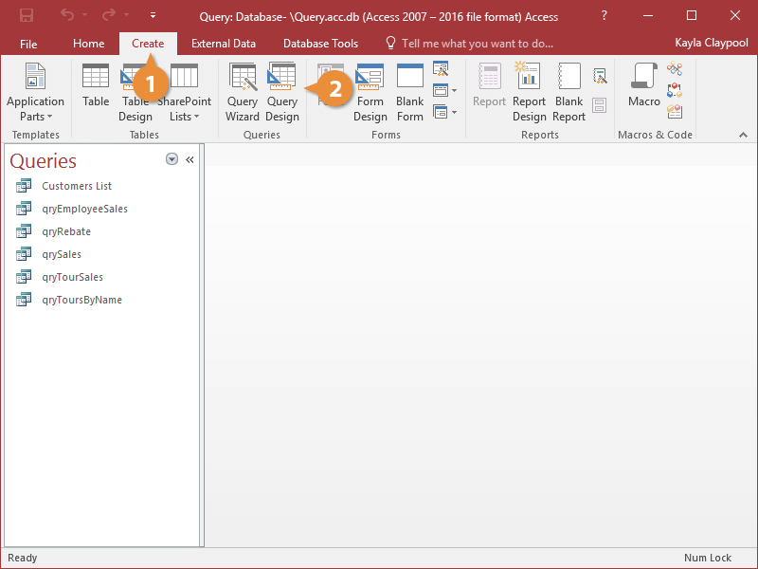

The Show Table dialog box appears.

Follow the onscreen instructions to create the query.

Select the table(s) you want to add to the query and click **Add**.

Click **Close**.

You can also add tables to a query by dragging them from the Navigation Pane to the top half of the Query window.

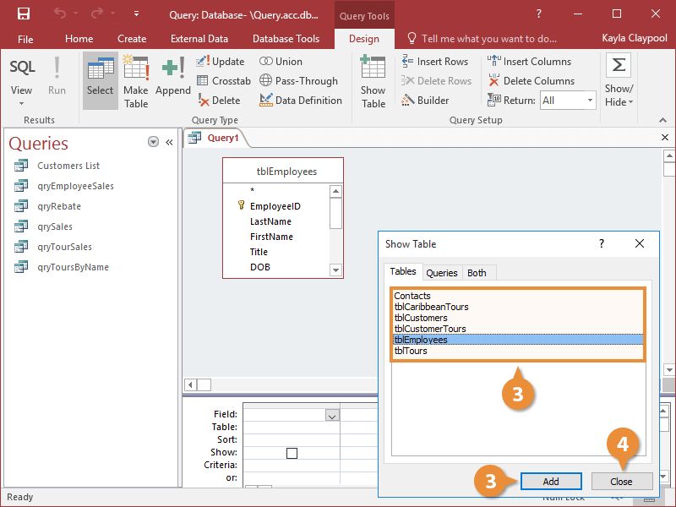

The Query window appears in Design View. Notice that the window is split. The top half contains a box that displays all the fields in the table you added to the query. The bottom half of the screen contains a design grid, which is where you will add the fields you want to appear in your query.

Double-click each field you want to include in the query.

You can also add fields by dragging the field from the field list onto the design grid.

Often you will have to use the field list's scroll bar to scroll up or down the list to find a field.

Now you need to specify any criteria for the query. Enter the criteria in the design grid's Criteria row. For example, you could select to see only records whose City field contains "London", or you could enter K* to return only results that begin with K.

Enter any search criteria for the field in the **Criteria** box.

Deselect the **Show** box for a field if you want to use a field in a query but you don't want it to be displayed.

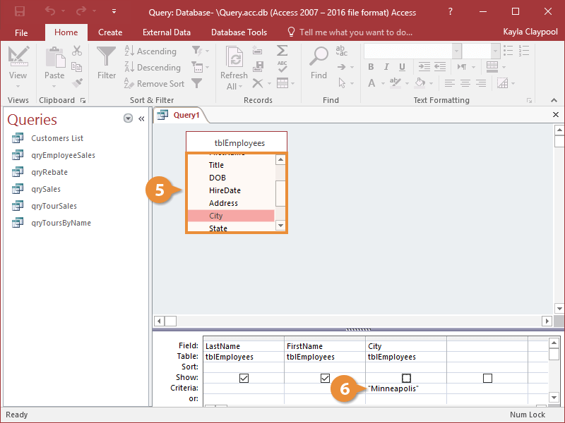

**Save a Query**

Once you have created a query, you'll want to save it to use later.

Click the **Save** button.

Enter a name for the query.

Click **OK**.

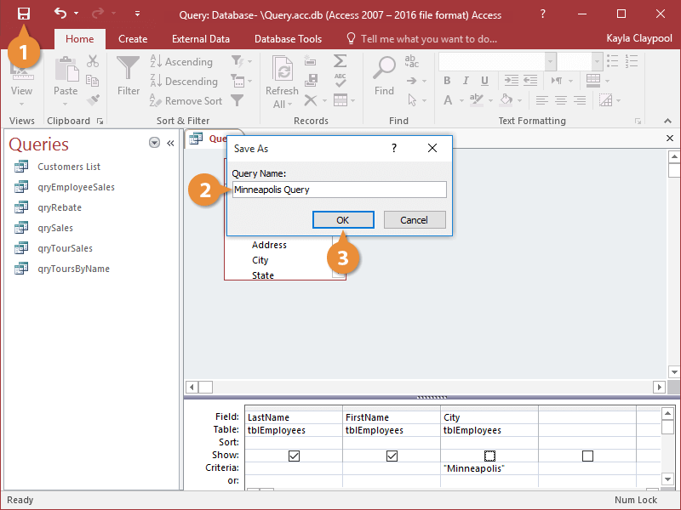

The query is saved and now appears in the Navigation Pane.

Run a Query

Your queries run when you open them through the Navigation Pane.

Open the query or click the **Run** button if you're in Design view.

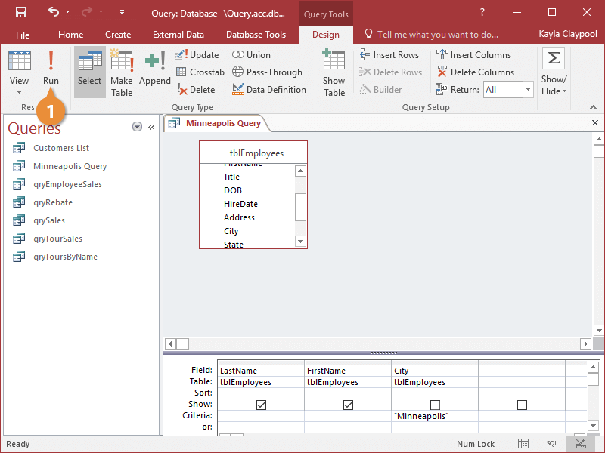

Access displays the results of the query.

**Relationships**

You may well be familiar with the term 'Relational Database' already, but perhaps don't understand what it means. If that is the case, then, hopefully, this should put you on the right track to penetrating the meaning of the term. Relational Database design is all about how database tables are connected with each other. Whilst the novice database designer will create one single table with lots of fields, the relational database designer will look at the the data that needs to be stored and will put it together in a number of groups

1. The first step is to create a new Access Database. Lets call it Customer Orders.
2. Next create a new table called **tblCustomers** with the following fields - ID (autonumber, primary field), FIRSTNAME (text), SURNAME (text), ADDRESS1 (text), CITY (text), and POSTCODE (text).
3. Create a new table called tblOrders with the following fields - ORDERID (autonumber, primary field), ITEMORDERED (text), DATE (date), PRICE (number, set the format property to currency), CUSTOMERID (number). CustomerId is going to be the foreign field when we create the relationship.
4. To create the relationship, select the DATABASE TOOLS RIBON and click the RELATIONSHIPS icon (from the SHOW/HIDE group).

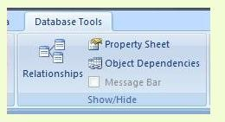

1. This opens the RELATIONSHIPS window. You will also see the pop up SHOW TABLE form the first time you open the window. We are now going to select which tables are going to be used in the relationship.

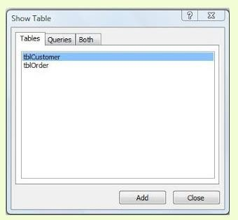

1. There are just two tables in our example database. Click on **tblCustomer** to highlight it in blue if it is not highlighted already. Then click add. Do the same for **tblOrder**, then close the pop up SHOW TABLE form.You should now see the two tables represented as separate box's in the RELATIONSHIPS window. You will notice in the diagram below that each box has it's fields .
2. listed and primary keys indicated.

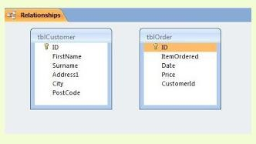

1. We will now click the ID field in **tblCustomer** and drag it to the CUSTOMERID field in

**tblOrder**. Notice the mouse pointer image changes from a circle with a line across to a plus sign as it hovers over the fields in tblOrder. When you release the mouse button at the end of the click and drag operation, a new EDIT RELATIONSHIPS pop up form opens.

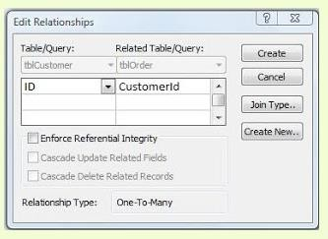

1. Click the three tick boxes which say ENFORCE REFERENTIAL INTEGRITY, CASCADE UPDATE RELATED FIELDS, and CASCADE DELETE RELATED RECORDS. We won't be going into what these do in this blog post.

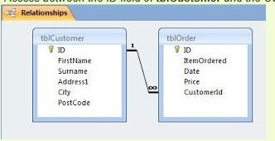

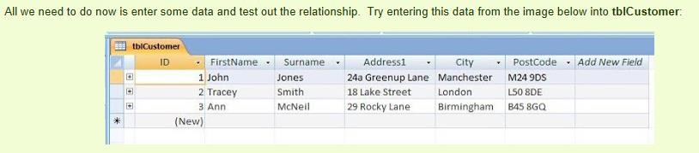

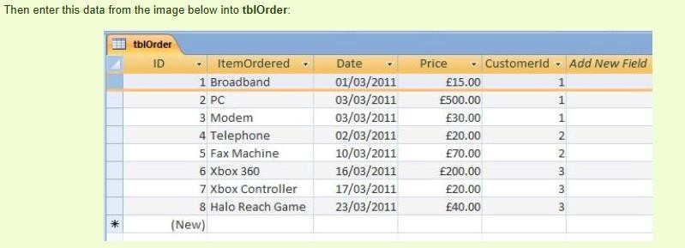

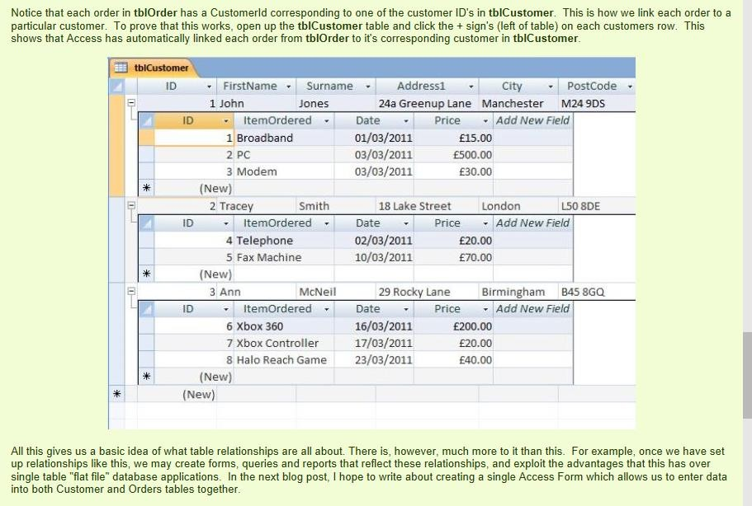

## **Lab Tasks**

**Task # 01:** Create a table “Customer” and add the following fields in the Customers table.

First Name  
Last Name  
City  
Zip Code

Create a Query and Set the following criteria:  
In the City field, type "Islamabad" to return only records with Durham in the City field.  
In the Zip Code field, type "27514" in the or: row to return records that are either in Islamabad or zip code 27514.

**Task # 02:** Create following tables:

Table Name:tblCustomer, tblOrders

Insert three records into this table and find the given relationship among them and save the results.

